Q1 (a) 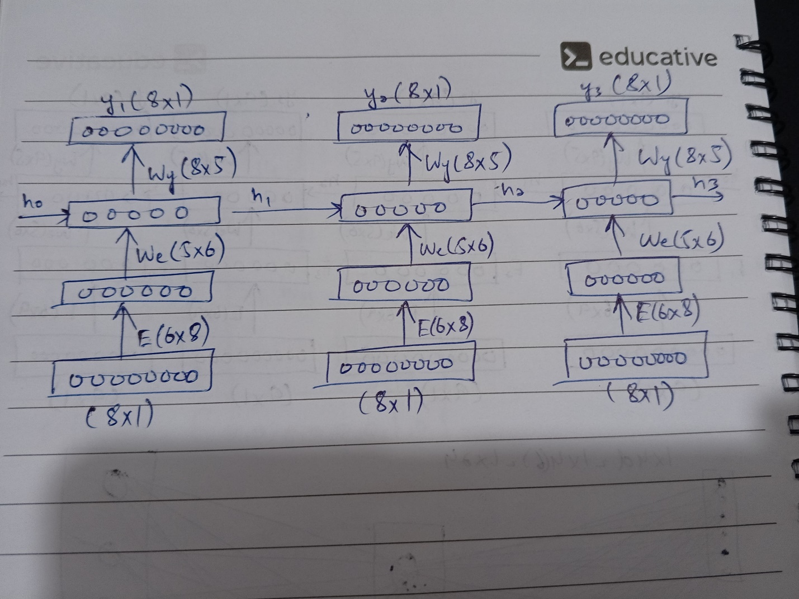

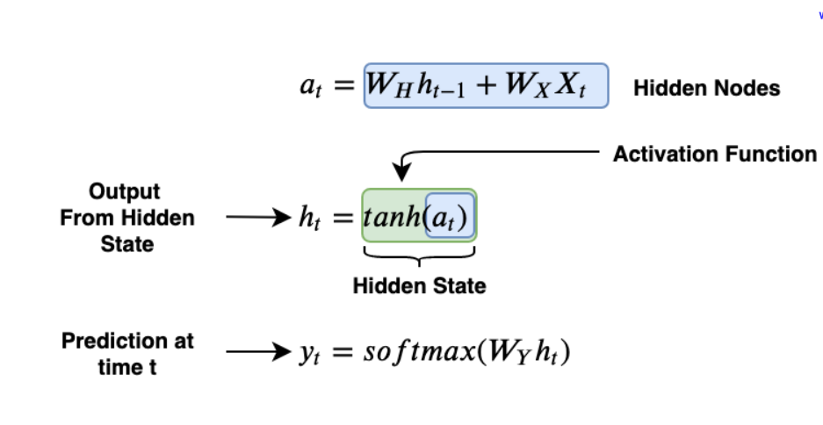

(b) Total Number of Parameters= 4 (E, Wx, Wh, Wy)

Q2 (a)

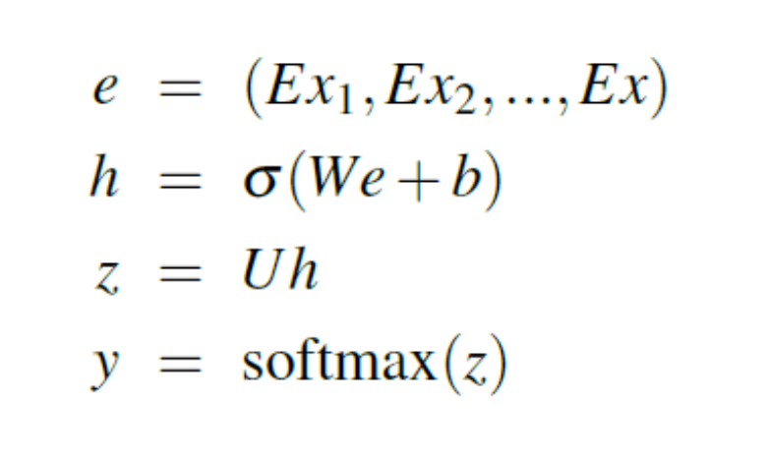

(b) Total Number of Parameters= 3 (E,Wx,Wy)